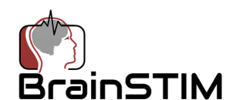
Date:

We cordially invite you to attend the 5th Annual Brain Stimulation and Imaging Meeting (BrainSTIM 2019 meeting https://www.brainstim-meeting.org/ ) which will be held June 7-8, 2019 at the Cattolica University Congress Center, Rome, Italy.
Like its predecessors, BrainSTIM 2019 will focus on the combination of brain imaging and stimulation. The meeting will have keynote lectures by leaders in the fields of imaging and stimulation, oral sessions selected from submitted abstracts, poster sessions and other opportunities to network. The meeting is designed to inform and educate all who are interested in these topics, from novices to experts.
This invitation does not include any financial support for travel, registration fees or local expenses.
Please feel free to inform us if you have any questions and/or additional requests. We look forward to seeing you in Rome!
Vincent Clark
Vincent P. Clark, PhD
Committee Chair BrainSTIM 2019
Phone: +1 (505) 400-5230

